spring 2025
Cse-4377 wireless communication systems
the university of texas at arlington


lab 6 report
Submitted toward the partial completion of the requirements for CSE 4377
Under the guidance of
Prof. Jason Losh
By:
Joshua Martinez, 1001374818

Introduction
For this final lab, it will explore into signal reception and demodulation. This will utilize sections from each previous lab, so that the expected setup will be the signal modulation circuit outputting a signal through our team’s antenna, which will be grabbed from a receiver antenna which will feed the signal into a SDR receiver attached to a raspberry PI, creating an IQ file. Using various signal processing methods through MATLAB, we will attempt to recover and read the received signal and compare it to the original signal. To begin with this lab, we must again properly setup up the equipment to follow regulations after creating a preamble setting in our modulator code.

Steps 1-10: Preamble Sequence and FCC regulations
Prior to the lab, the option to output a preamble sequence before transmitting our data stream is needed. The preamble will allow us to recognize the start of the received data based on the known data bits. So even if the received constellation is rotated, we may Identify the correct I and Q axis of it from the preamble. For our team we decided upon a preamble of 0x00008000. Since we will be using the QPSK modulation, two data bits are used for each symbol and with this preamble of ours, we will expect 0b00 and 0b10. In our code, this correlates to I and Q maximum and minimum values. Therefore, the preamble should begin in one quadrant and stay there for eight symbols, be in the opposite or furthest quadrant for 1 symbol, and return to the previous one for 7 symbols. Thus, when we can view the obtained transmission, we will search for the long pause at one location with 1 outlier before the reset of the data transmission.
Another important issue which appeared in previous labs, this lab will operate using an RF signal generator. The transmitted signals from this device must not be on restricted bands and exceed the allowed power limits. As we intended to use our antenna for this lab, we used 725 MHz frequency on the machine, which is a safe output, however, we didn’t have enough time to capture data using our antenna. When we began the lab, we used -81 dBm on the RF signal generator connecting to the RTL-SDR receiver, which needs an input of around -84.5 dBm. The set power level of the generator will roughly meet the -84.5 dBm requirement due to the loss incurred from the wire into the receiver and was verified to be true on the spectrum analyzer. To finish setting up the lab, we connect our modulation circuit with the red board programmed to the IQ connections to the RF signal generator. From here, the next step was to verify we connected everything properly with the TA. Afterwards, we can move onto the next steps.

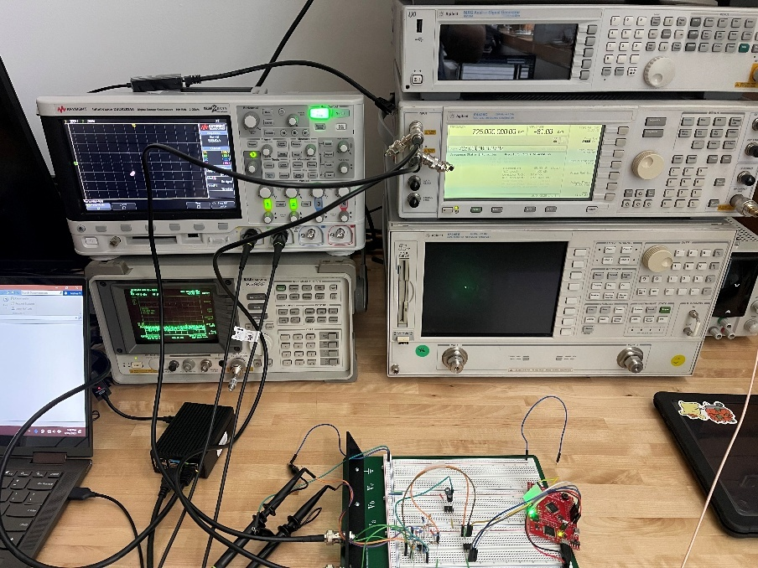
Figure 1. Lab setup using the RTL-SDR Receiver without antennas

Steps 11 - 15: RTL-SDR Receiver and MATLAB
With the lab setup finished, we can move onto capturing data using the RTL-SDR receiver connected to the raspberry PI. After connecting to the PI remotely, we can use a given terminal command to capture a second of data at 2.048 Mbps including our selected frequency, 725 MHz. The preferred method of data transfer is to begin transmitting within the second of data capturing so we may be able to see the beginning of the signal and what to look out for. A sample test was taken, captured, and sent to our pc from the PI to help with the MATLAB steps.
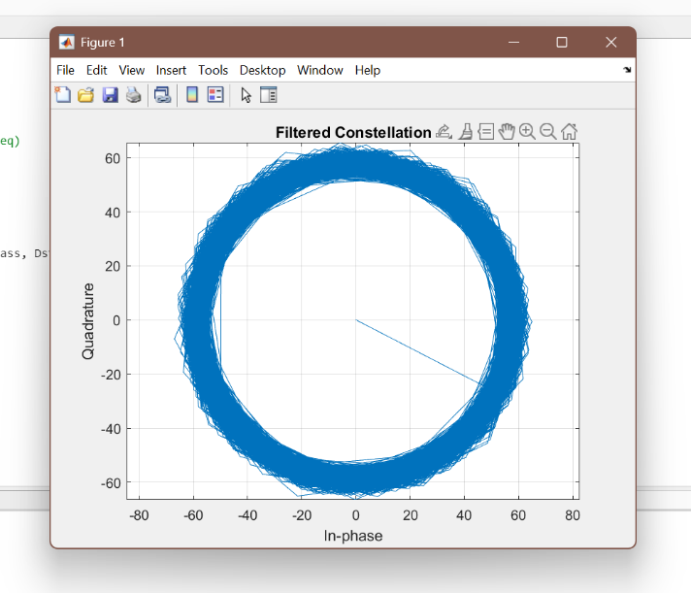
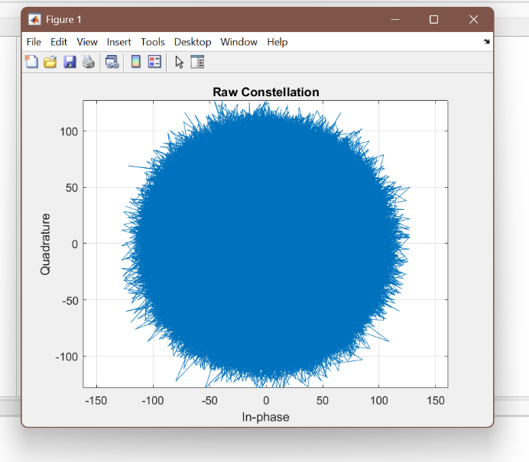
The captured IQ file from the PI has its values stored in an 8-bit offset unsigned format (IQIQIQIQ…). With it being unsigned, the max value is at value 255 whereas the lowest is at 1, and it correlates to the +/- 0.5 amplitude from the circuit (making 128 have a value of 0 voltage). Code has been provided to open this file and read the described values: create a length variable to match the 2.048 Mbps, open the desired file in MATLAB to a variable, create an empty array using the length variable, and in a for loop, read and format the IQ data pair properly, and store it into the array. When done, the ‘rx’ array will contain complex data values from the file, however, this result will be very noisy when put into a complex plane. To help correct the noise, a FIR filter with an 8 KHz cutoff frequency has been given. This filter also contains a stopband of around 64 KHz, which heavily attenuates frequencies above it. This filter is then convolved with the ‘rx’ signal. With the signal filtered, it will then be decimated, or reduced, by dividing the length by 8000, reducing the data size, and therefore reducing the noise. Overall, this filter sets a passband for the 8 KHz frequency, attenuates 64 KHz or louder noise, and shrinks the dataset and improves the complex plane of the test sample leading to a donut shape rather than a large blob. Although the signal has been cleaned up, the shape of the plane is still wrong. Since the test signal was a DC value, the I and Q planes do not change throughout the transmission. The reason for the donut shape in the complex plane is due to a difference in the transmit and received frequency of the RF signal generator and SDR receiver, leading to the signal rotating. To fix this issue, each data point needs to multiply with a rotating phase, the code has been given as well. Through the chosen frequency offset in the equation, the pre filtered dataset will have an added rotation to all the points and shifting them accordingly. By tweaking the frequency value, eventually all the data points can be rotated into a tight spot in the complex plane. This value can be found easier when decreasing the length of data used, using 10ms of data and working up to the full 1 second after testing the rotation at various increments. When the donut can be transformed into a single dot, we can move onto the next steps.

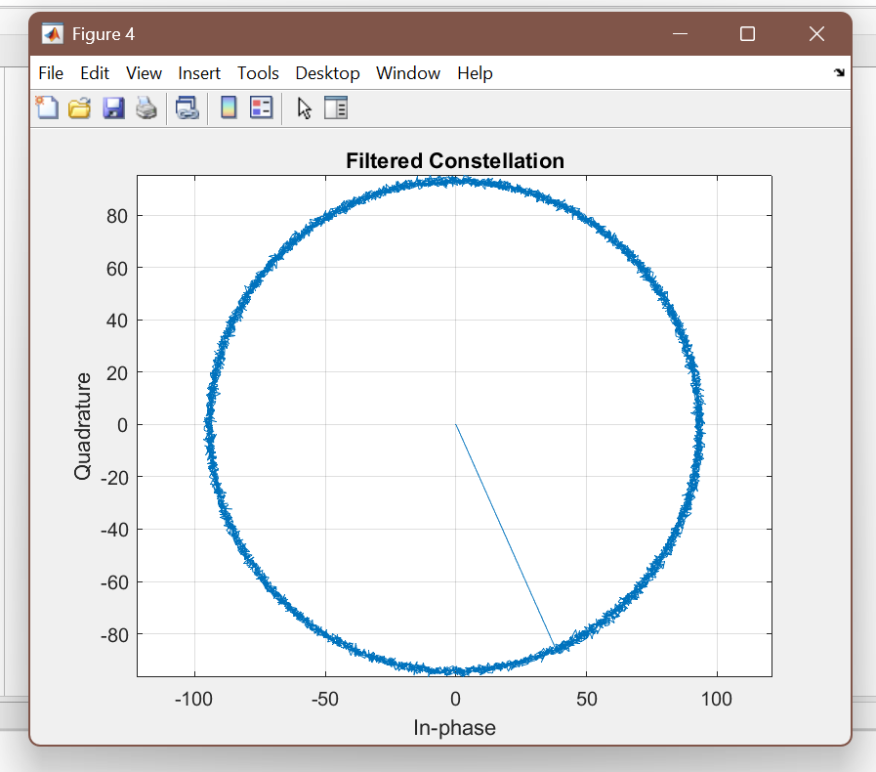
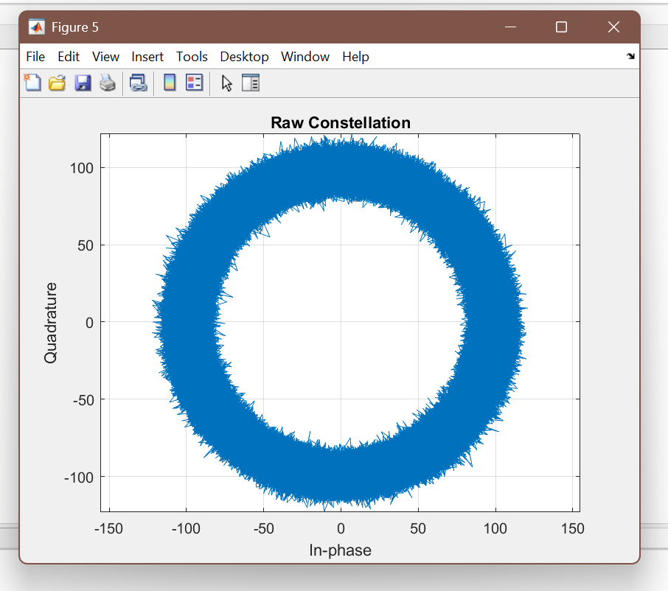
Figure 2 & 3: Unfiltered and filtered captured data from antenna attempt, leading to setup change

Figure 4 & 5: Unfiltered and filtered DC output from red board to SDR receiver
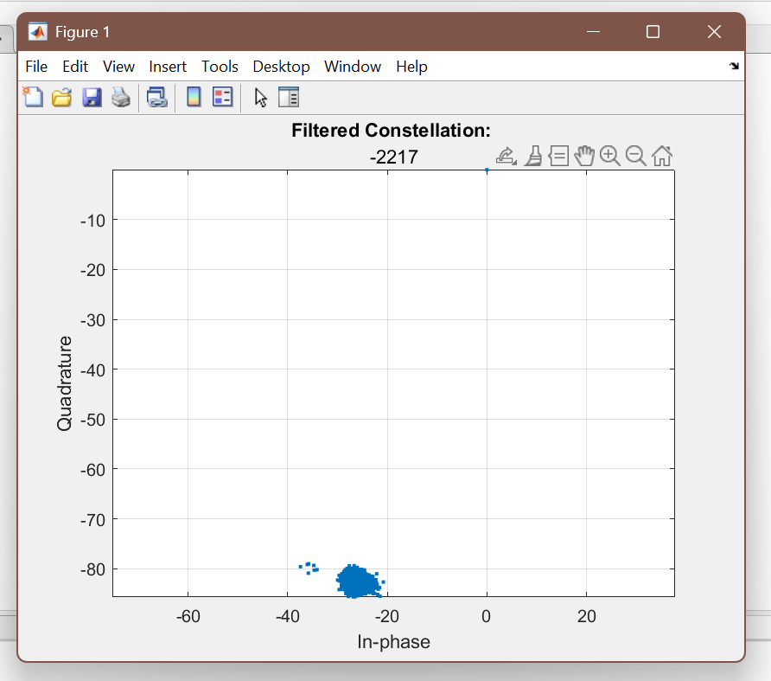
Figure 6: DC test 1 used to find frequency offset

Steps 16 -18: DC, Sine/Cosine, and QPSK Mod. Output W/O Preamble
With the test DC output completed, using the found frequency offset, which was around 2200, we subtracted this amount from the RF signal generator, bringing the frequency down to about 724.9978 MHz. With this change in place, we tested it by outputting 0.5 + j0, or 0.5 DC output, from our modulation circuit into the RF signal generator and recapture this data using the SDR receiver. This test was verified using the MATLAB code from earlier, but with no frequency offset, as it’s been accounted for. The result of this is the same fuzzy dot previously noted, but requiring an offset of around 4 Hz. As this seemed acceptable, we moved onto the next step of outputting a 1 KHz tone on the dual DAC, Sine and Cosine on I and Q. After ensuring this output is correct using the oscilloscope, we captured this data using the receiver. Although, the lab document notes to add a 1 KHz offset when de-rotating the data, the previously used ~4 Hz offset was enough to realign the constellation. Despite this, the test seems to be correct, and we moved onto the next step.
For the last test of this section, we will output QPSK modulation at 8ksps with RRC filter off. At this rate, it should FIR filter in MATLAB will correlate the data bits correctly at this speed. After capturing this modulated transmission, the constellation was rotated, but still slightly spinning, as shown in the following images. Due to the modulation added to this constellation, there should be 4 distinct spots to look for when correcting the offset, which we do find. For this test, an offset of around 9-16 Hz (using various test attempts) mostly fixed this issue, and due to time constraints, we decided this was good enough to move onto the last section.

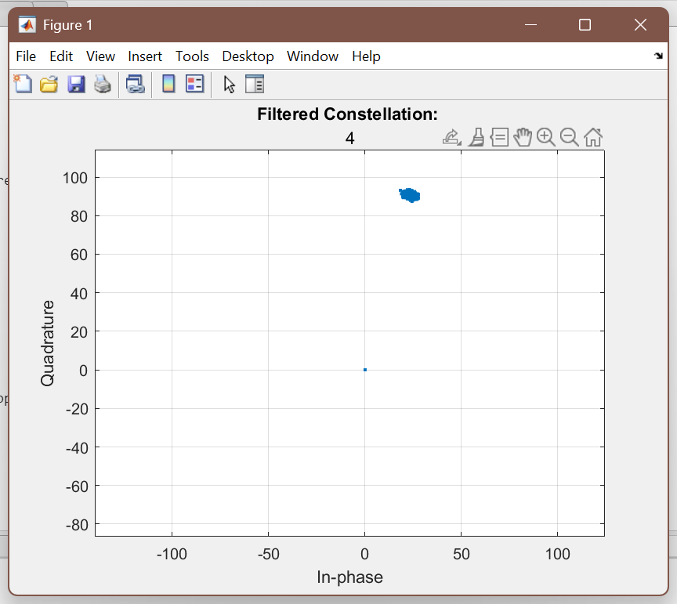
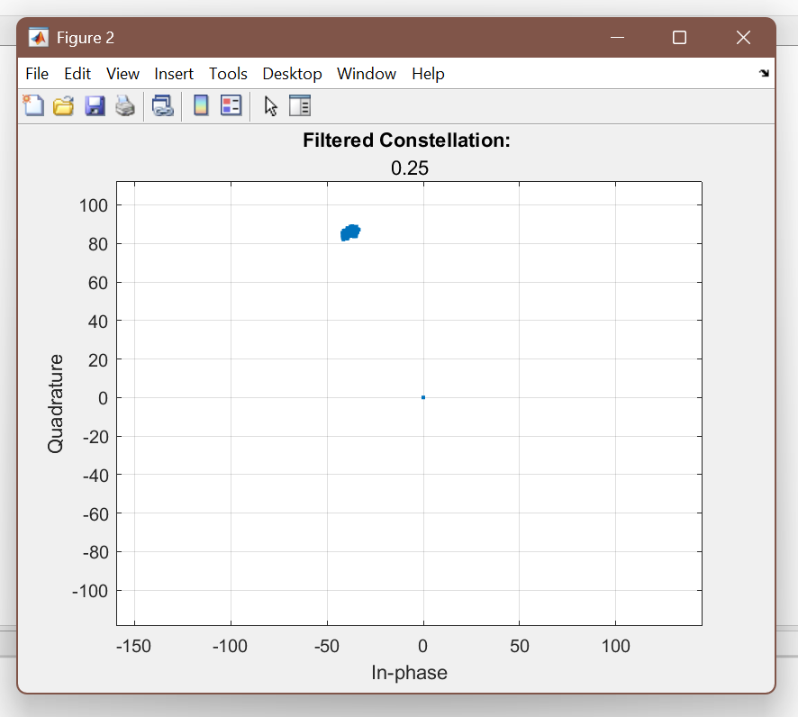
Figure 7 & 8: DC test 2 (left) and test 3 (right) used to verify offset properly handled after DC output
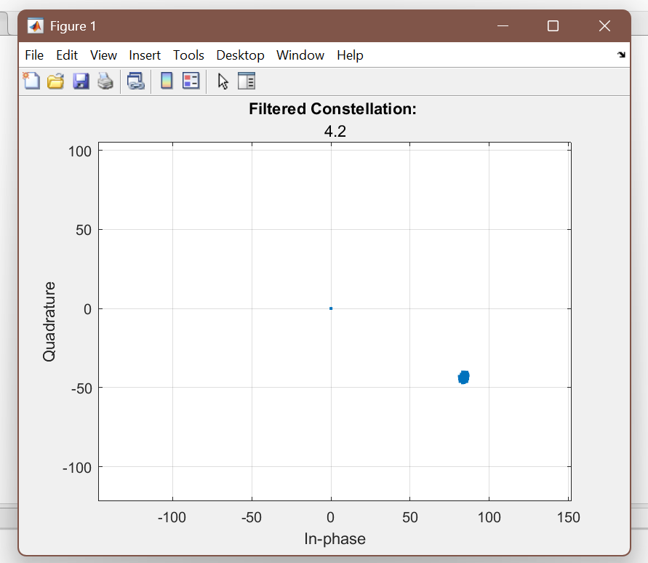
Figure 9: dual DAC with 1 KHz output with around 4 Hz offset instead of 1 KHz

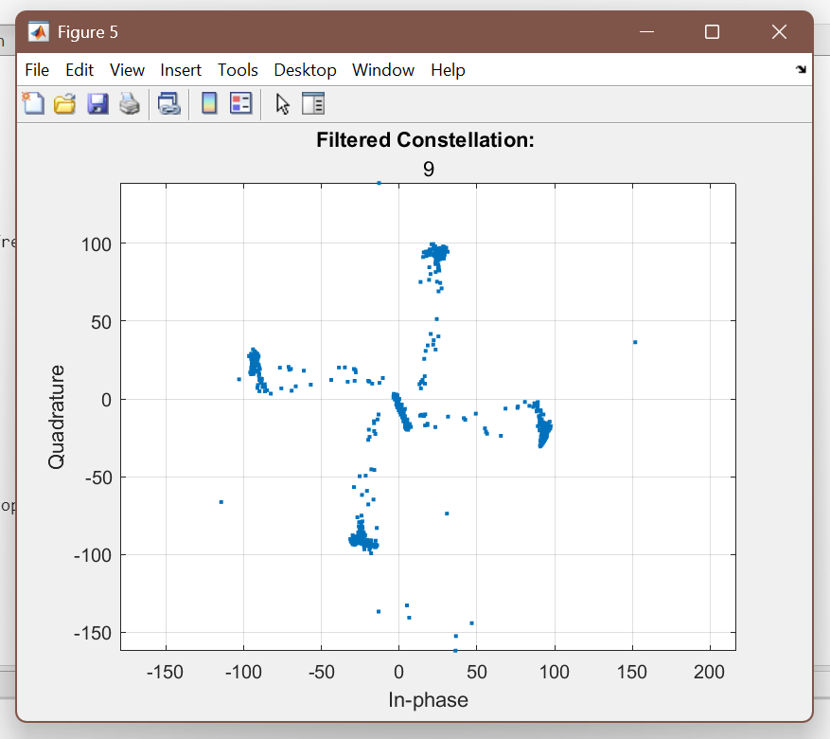
Figure 10: one of the QPSK modulation output with a slight offset needed (line of noise in middle)

Steps 19 -21: QPSK W/ Preamble Demodulation and BER
From the previous step, we were able to correctly derive 4 distinct points to match the QPSK quadrants that happen due to modulation. However, we can’t identify the I and Q axis of this constellation. Thus, the next step requires adding the created preamble from step 1 and recapture test data with QPSK modulation. After filtering the data, and correcting the slight rotation we still have, we will need to identify the start of the transmission, the preamble. As stated, we have some rotation still in our signal, which causes the rotating center bar in our test data, which should be noise near the zero mark. Our team used code to find each point on the constellation in the order they appear. Eventually, the preamble was found when the plotted data point shot out into a quadrant for a few points, and launched across to the opposite, before returning and settling into one of the paths for a fuzzy point. With this, we could identify the I and Q axis despite the constellation being rotated. Based on our code: 0b00 is top right, 0b01 is top left, 0b10 is bottom left, 0b11 is bottom right. In other words, our quadrants go counterclockwise with bits 0b00 starting top left.
For the last step, we are to compute the BER (bit error rate) in our transmission. To accomplish this, we need to decipher which quadrant each fuzzy dot belongs to thanks to our preamble. Then, using the data stream we output, which is a constant value, we can calculate the BER based on how much the transmission matches the data stream after the preamble. As shown in the table below with 300 symbols or 600 bits, there was no bit error rate in the recorded data. There seemed to be two extra 0b00 symbols prior to the start of the bit stream data, but they might have been caused for some other reason and won’t count towards the BER. This IQ test file was captured without antennas, but did have a 0.0% BER showing it had excellent transmission accuracy at least, and this concluded the lab.

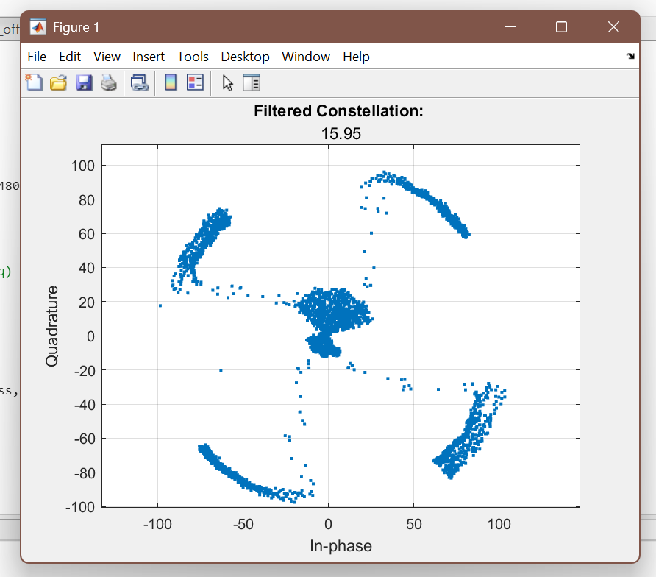
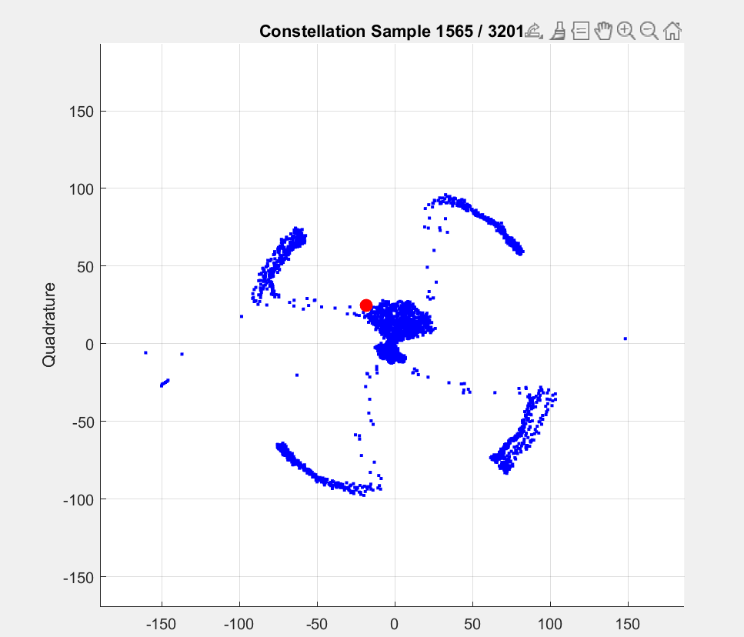
Figure 11: QPSK modulation with preamble output with a slight offset needed (rotating issue persisted)

Figure 11: Presumed start of preamble as noise was on right side of fan shape center noise

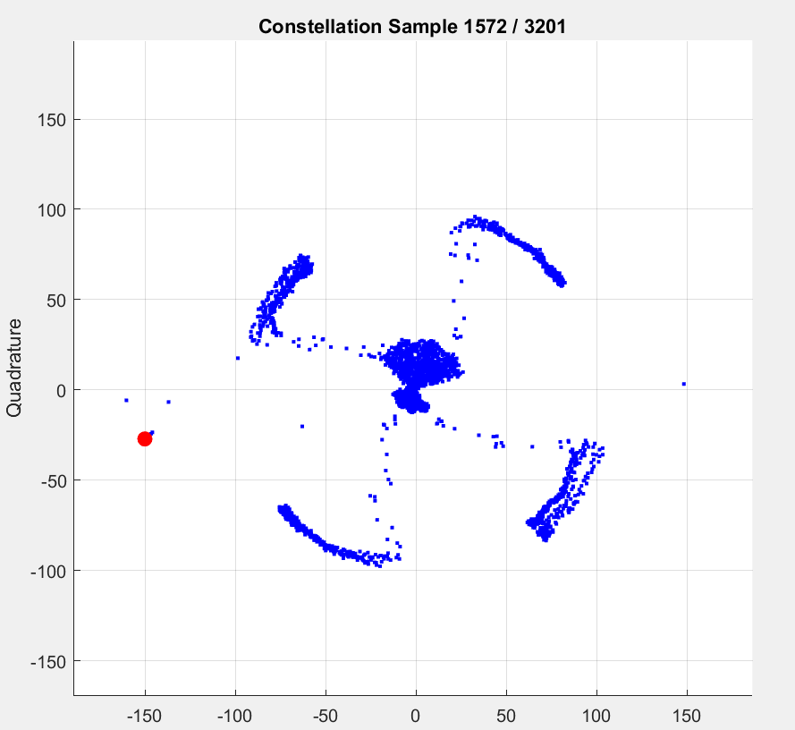
Figure 12: Second to last zero before 0b10 preamble variable (noting this cluster mainly 0x0000)
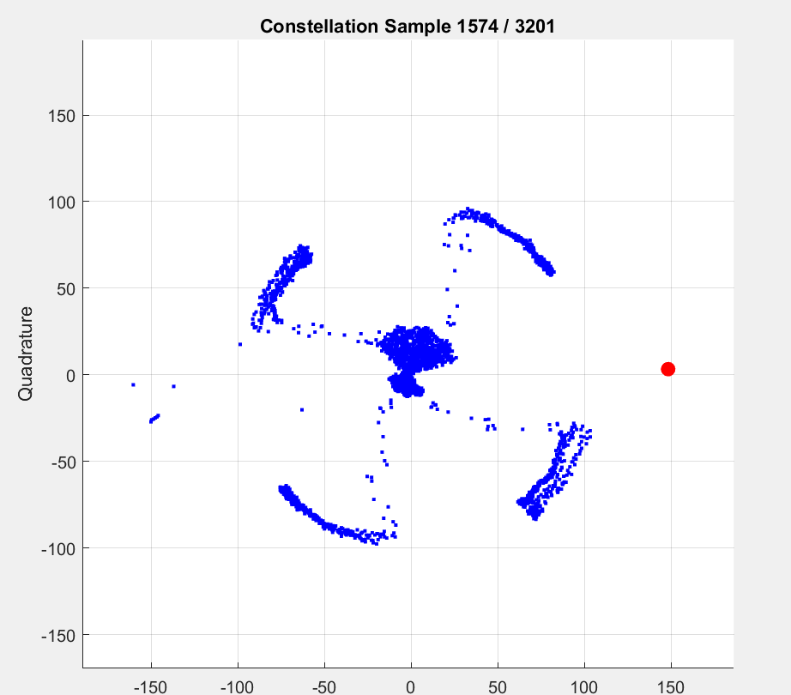

Figure 13: 0b10 bit of preamble (connected to the quadrant facing bottom right)

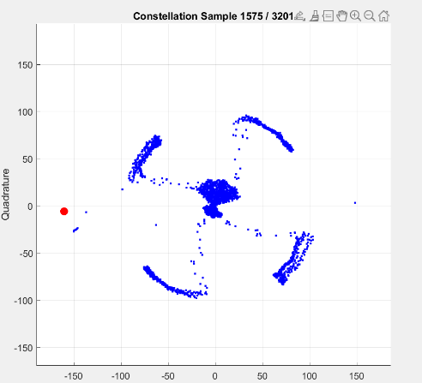
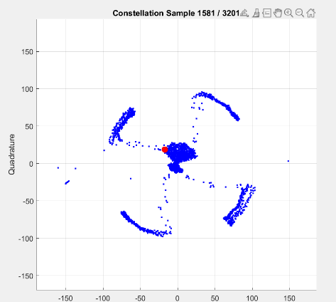
Figure 14: first 0b00 bit of preamble after the noted 0b10

Figure 15: Presumed end of preamble noting the quadrant value
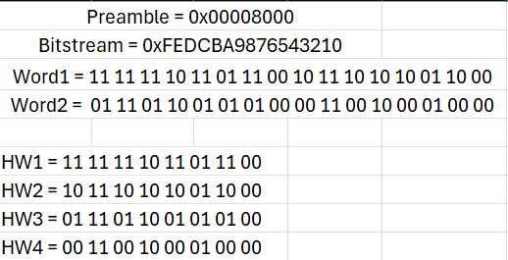
Figure 16: Values used for preamble and bitstream (w/ bitstream dissected for easier symbol comparison)
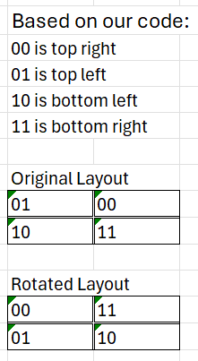

Figure 17: Original quadrant layout compared to IQ file’s constellation

Examined Range: 1584 - 1884
1584: | 10 11 10 10 10 01 10 00
 | 01 11 01 10 01 01 01 00
 | 00 11 00 10 00 01 00 00
 | 11 11 11 10 11 01 11 00
 | 10 11 10 10 10 01 10 00
 | 01 11 01 10 01 01 01 00
 | 00 11 00 10 00 01 00 00
 | 11 11 11 10 11 01 11 00
 | 10 11 10 10 10 01 10 00
 | 01 11 01 10 01 01 01 00
1664: | 00 11 00 10 00 01 00 00
 | 11 11 11 10 11 01 11 00
 | 10 11 10 10 10 01 10 00
 | 01 11 01 10 01 01 01 00
 | 00 11 00 10 00 01 00 00
 | 11 11 11 10 11 01 11 00
 | 10 11 10 10 10 01 10 00
 | 01 11 01 10 01 01 01 00
 | 00 11 00 10 00 01 00 00
 | 11 11 11 10 11 01 11 00
1744: | 10 11 10 10 10 01 10 00
 | 01 11 01 10 01 01 01 00
 | 00 11 00 10 00 01 00 00
 | 11 11 11 10 11 01 11 00
 | 10 11 10 10 10 01 10 00
 | 01 11 01 10 01 01 01 00
 | 00 11 00 10 00 01 00 00
 | 11 11 11 10 11 01 11 00
 | 10 11 10 10 10 01 10 00
 | 01 11 01 10 01 01 01 00
1824: | 00 11 00 10 00 01 00 00
 | 11 11 11 10 11 01 11 00
 | 10 11 10 10 10 01 10 00
 | 01 11 01 10 01 01 01 00
 | 00 11 00 10 00 01 00 00
 | 11 11 11 10 11 01 11 00
 | 10 11 10 10 10 01 10 00
1880: | 01 11 01 10 01

Table 1: List of recorded symbols starting at presumed started at 1584

Conclusion
This lab helped tie together the full process of wireless communication, going from transmitting signals through antennas to receiving them via another antenna and demodulating them to read the data. This lab helped going through one method of applying signal processing to help clean IQ data captured on the RTL-SDR Receiver and show the results onto MATLAB. It also showed the importance of a signal’s preamble as it informs the receiver how the captured signal has been rotated to better read the data as well as calculating our Bit Error Rate from this lab. Overall, this lab helped solidify the entire routine needed to transmit a signal from one end to another where it’s deciphered and read.

